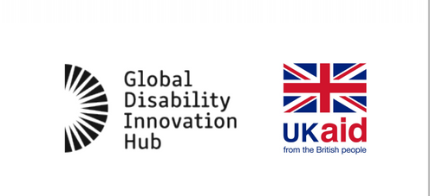
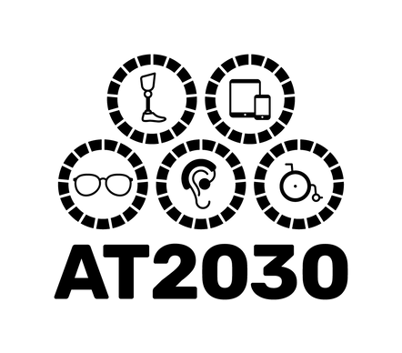
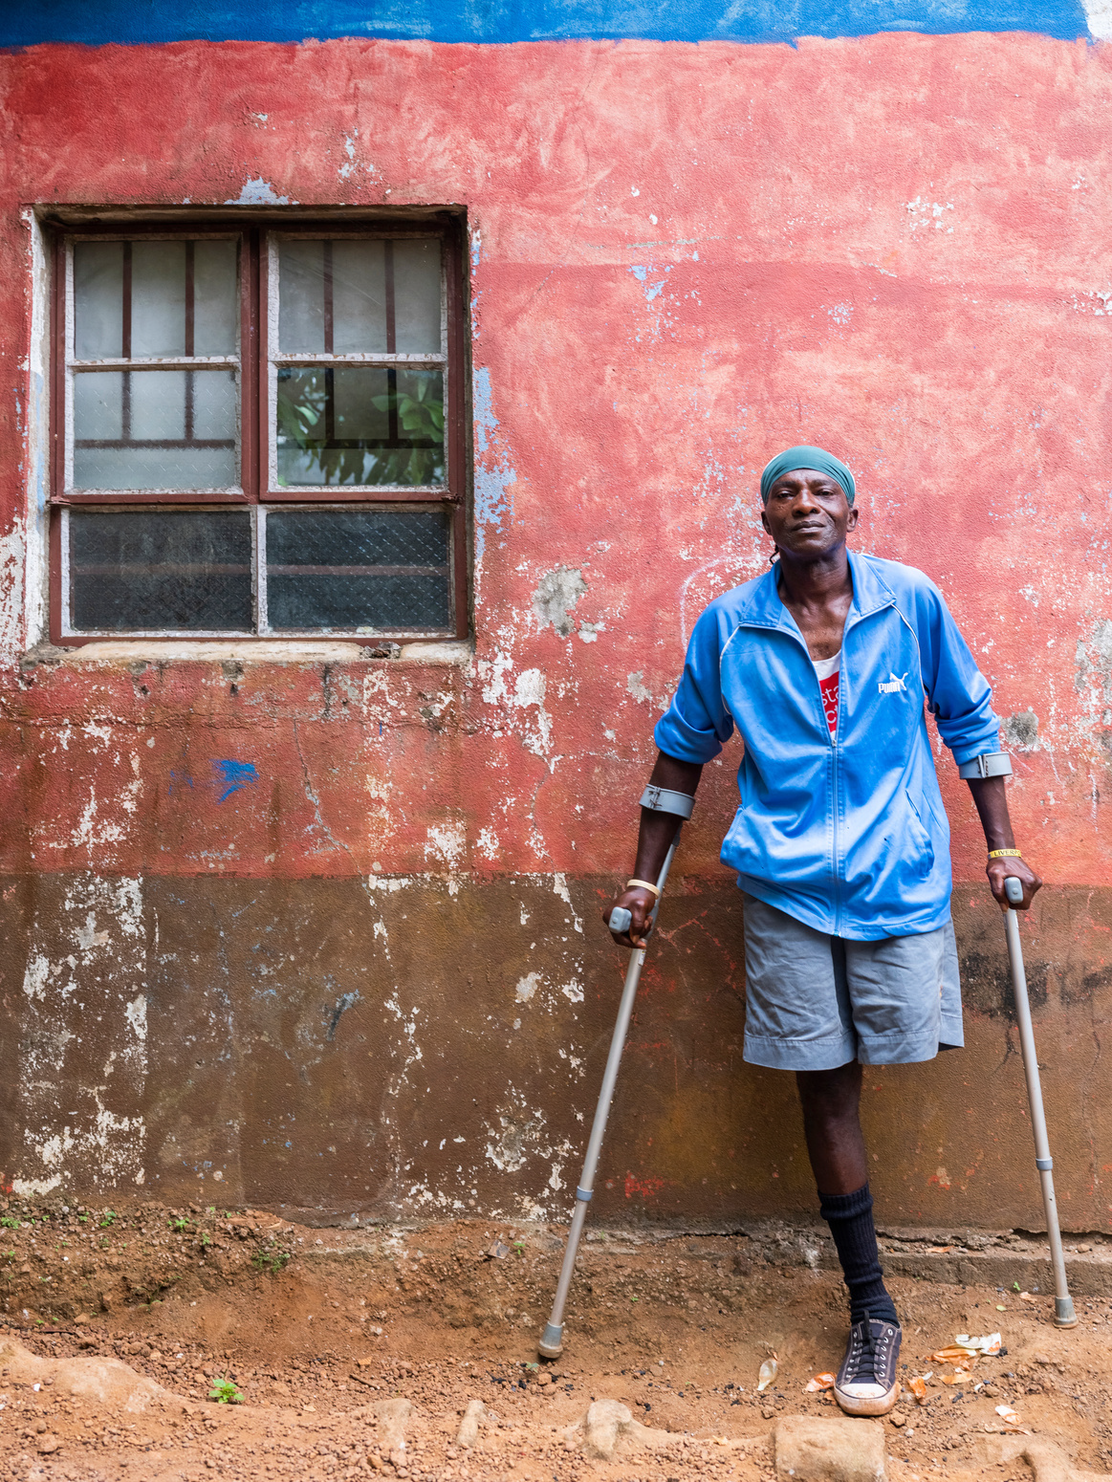

AT2030 Midterm Impact Summary

Testing ‘what works’ to enable access to life-changing assistive technology for all.
AT2030, funded by UK Aid, is testing ‘what works’ to enable life-changing assistive technology (AT) for all.

A Global Challenge
AT, such as glasses, wheelchairs, communication devices, pressure mattresses and incontinence products enable people to fully participate in life and realise their human rights but there are 900 million people globally without the assistive technology they need.
There are 1.2 billion disabled people globally, set to rise to 2.5 billion by 2050. With 80% of disabled people located in the global south, poverty and disability are intrinsically linked and compounded by a lack of access to AT. Our world’s infrastructure also often excludes as does disability stigma, which is why AT2030 also turned its attention to the enabling environment through inclusive design and enabling attitude change.

AT2030
AT2030, a £40 million programme funded by UK Aid, was designed to explore, and test innovative ways to address these systematic challenges, and to get more AT to the people that need it around the world.
The five-year AT2030 programme officially started in October 2019. AT2030 aimed to reach 9 million people directly and 20 million more indirectly to enable a lifetime of potential through life-changing AT.
AT2030 has created successful initiatives including the Assistive Tech Impact Fund (ATIF), which has supported 5 of the most promising African AT ventures with catalytic funding and technical advice, and, Innovate Now, Africa’s first AT accelerate.

AT2030 clusters
- Data, Evidence & Impact: Improving data and evidence to unlock investment into AT
- Innovation: Supporting new products and service delivery models to scale
- Country Implementation: Laying the foundations for market shaping and systems-level change
- Building Capacity and Participation: Building community solutions, maximising the power of the Paralympics to overcome stigma and promoting inclusive design

AT2030 Impact
Now, 3 years in and operational in 35 countries, AT2030 can share the impact so far:
- 5 million people reached directly
- 16.6 million people reached indirectly
- £13 million raised through match funding
- A+ rating from the Foreign Commonwealth and Development Office in 2019-2020. Recognised as; excellent ‘Exceeding Expectations’ by funders UK Aid
- 10 Country Capacity Assessment (CCAs), and 10 countries with CCA Action Plans complete
- 9 innovative service delivery models on track to scale
- 63 partnerships to support AT capacity
- 10 innovative AT products supported
- 27 AT ventures supported sustainability
- 150 journal articles, influencing papers, and insights answering critical research questions published
- 47 countries could watch the Paralympics for the first time across Africa
- 32 countries implementing AT2030 ideas

Where we work
AT2030 is testing ‘what works’ in over 35 countries, including:
- Bolivia
- Dominican Republic
- Ghana
- Zambia
- Nigeria
- Tanzania
- Malawi
- Rwanda
- Mongolia
- India
- South Africa
- Jordan
- Vietnam
- Japan
- Liberia
- Sierra Leone
- Kenya
- Indonesia
- Tajikistan
- Nepal
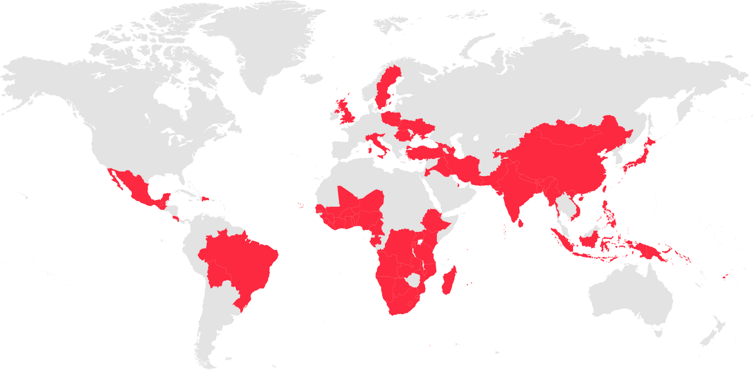

Further resources
Find out more about the AT2030 programme using this link: https://at2030.org/.
Discover out AT2030 Partners using this link: https://at2030.org/partners/

